- Display the names of employees from department number 10 with salary greater than that of any employee working in other departments.
SELECT ename
FROM employee
WHERE deptno = 10
AND sal > ANY (SELECT sal FROM employee WHERE deptno <> 10);
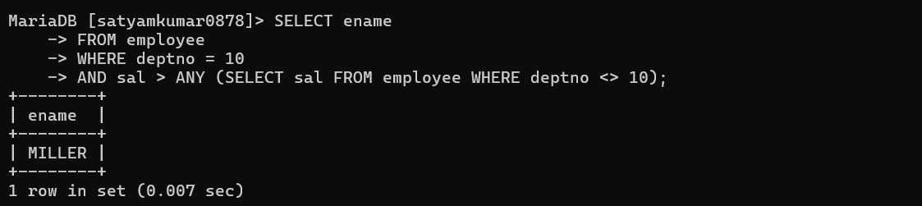
- Display the names of employee from department number 10 with salary greater than that of all employee working in other departments.
SELECT ename
FROM employee
WHERE deptno = 10
AND sal > ALL (SELECT sal FROM employee WHERE deptno <> 10);
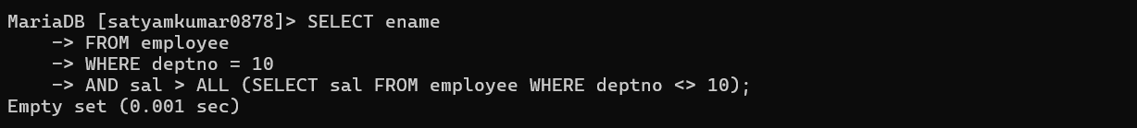
- Display the details of employees who are in sales dept and grade is 3.
SELECT e.*
FROM employee e
JOIN department d ON e.deptno = d.deptno
WHERE d.dname = 'SALES'
AND e.grade = 'C';
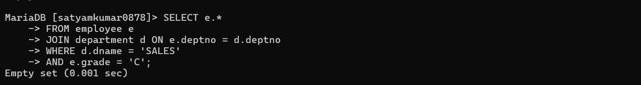
- Display those who are not managers and who are managers anyone.
SELECT ename
FROM employee
WHERE empno NOT IN (SELECT mgr FROM employee WHERE mgr IS NOT NULL);
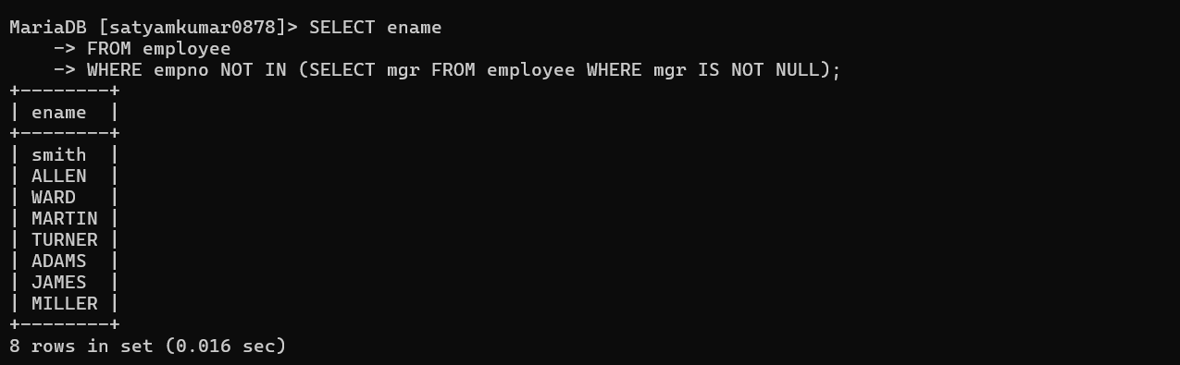
- Display those employees whose manager name is jones.
SELECT e.ename
FROM employee e
JOIN employee m ON e.mgr = m.empno
WHERE m.ename = 'JONES';
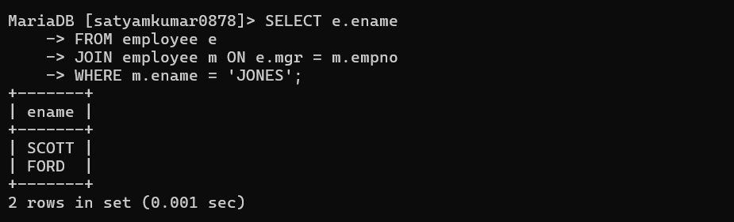
- Display ename who are working in sales dept.
SELECT e.ename
FROM employee e
JOIN department d ON e.deptno = d.deptno
WHERE d.dname = 'SALES';
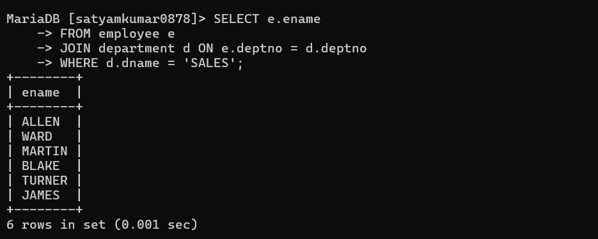

- Display employee name, deptname, salary and comm. For those sal in between 2000 to 5000 while location is chicago.
SELECT e.ename, d.dname, e.sal, e.comm
FROM employee e
JOIN department d ON e.deptno = d.deptno
WHERE e.sal BETWEEN 2000 AND 5000
AND d.LOCATION = 'CHICAGO';
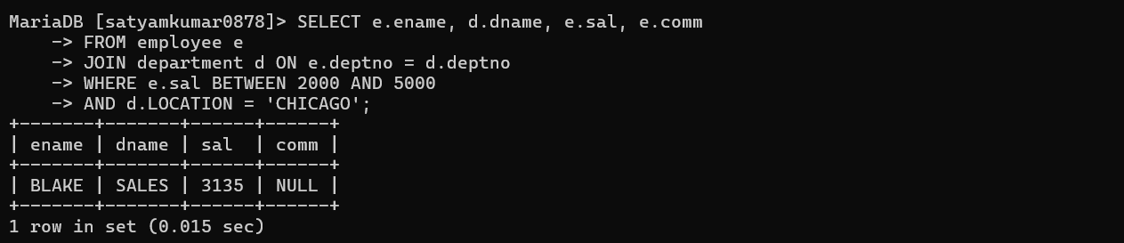
- Display those employees whose salary greater than his manager salary.
SELECT e.ename
FROM employee e
JOIN employee m ON e.mgr = m.empno
WHERE e.sal > m.sal;
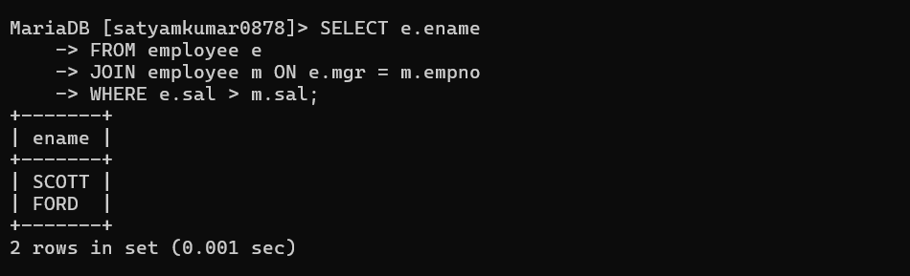
- Display those employees who are working in the same dept where his manager is working.
SELECT e.ename
FROM employee e
JOIN employee m ON e.mgr = m.empno
WHERE e.deptno = m.deptno;
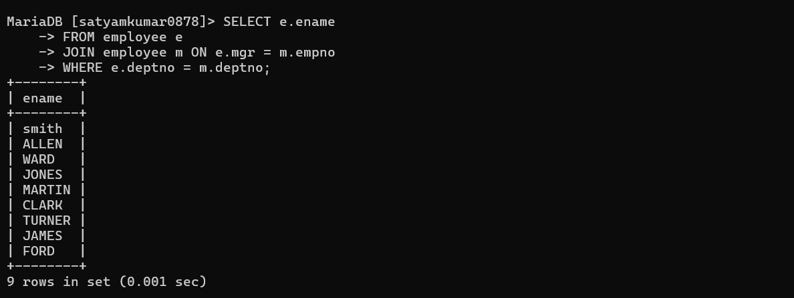
10. Display grade and employees name for the dept no 10 or 30 but grade is not 4, while joined the company before 31-dec-82.
SELECT e.ename, e.grade
FROM employee e
WHERE e.deptno IN (10, 30)
AND e.grade <> '4'
AND e.hiredate < '1982-12-31';
